

**BTC2202 / ICS2014 : Computer Organization and Architecture**

**Assignment #2: Number Systems Usage in Computer Systems**

<Odunga Vincent Onyango/122877 >

1(a)

Decimal Binary Hexadecimal

0

1 1 1

2 10 2

3 11 3

4 100 4

5 101 5

6 110 6

7 111 7

8 1000 8

9 1001 9

10 1010 A

11 1011 B

12 1100 C

13 1101 D

14 1110 E

15 1111 F

16 10000 10

17 10001 11

18 10010 12

19 10011 13

20 10100 14

21 10101 15

22 10110 16

23 10111 17

24 11000 18

25 11001 19

26 11010 1A

27 11011 1B

28 11100 1C

29 11101 1D

30 11110 1E

31 11111 1F

32 100000 20

33 100001 21

34 100010 22

35 100011 23

36 100100 24

37 100101 25

38 100110 26

39 100111 27

40 101000 28

41 101001 29

42 101010 2A

43 101011 2B

44 101100 2C

45 101101 2D

46 101110 2E

47 101111 2F

48 110000 30

49 110001 31

50 110010 32

51 110011 33

52 110100 34

53 110101 35

54 110110 36

55 110111 37

56 111000 38

57 111001 39

58 111010 3A

59 111011 3B

60 111100 3C

61 111101 3D

62 111110 3E

63 111111 3F

64 1000000 40

65 1000001 41

66 1000010 42

67 1000011 43

68 1000100 44

69 1000101 45

70 1000110 46

71 1000111 47

72 1001000 48

73 1001001 49

74 1001010 4A

75 1001011 4B

76 1001100 4C

77 1001101 4D

78 1001110 4E

79 1001111 4F

80 1010000 50

81 1010001 51

82 1010010 52

83 1010011 53

84 1010100 54

85 1010101 55

86 1010110 56

87 1010111 57

88 1011000 58

89 1011001 59

90 1011010 5A

91 1011011 5B

92 1011100 5C

93 1011101 5D

94 1011110 5E

95 1011111 5F

96 1100000 60

97 1100001 61

98 1100010 62

99 1100011 63

100 1100100 64

101 1100101 65

102 1100110 66

103 1100111 67

104 1101000 68

105 1101001 69

106 1101010 6A

107 1101011 6B

108 1101100 6C

109 1101101 6D

110 1101110 6E

111 1101111 6F

112 1110000 70

113 1110001 71

114 1110010 72

115 1110011 73

116 1110100 74

117 1110101 75

118 1110110 76

119 1110111 77

120 1111000 78

121 1111001 79

122 1111010 7A

123 1111011 7B

124 1111100 7C

125 1111101 7D

126 1111110 7E

127 1111111 7F

128 10000000 80

129 10000001 81

130 10000010 82

131 10000011 83

132 10000100 84

133 10000101 85

134 10000110 86

135 10000111 87

136 10001000 88

137 10001001 89

138 10001010 8A

139 10001011 8B

140 10001100 8C

141 10001101 8D

142 10001110 8E

143 10001111 8F

144 10010000 90

145 10010001 91

146 10010010 92

147 10010011 93

148 10010100 94

149 10010101 95

150 10010110 96

151 10010111 97

152 10011000 98

153 10011001 99

154 10011010 9A

155 10011011 9B

156 10011100 9C

157 10011101 9D

158 10011110 9E

159 10011111 9F

160 10100000 A0

161 10100001 A1

162 10100010 A2

163 10100011 A3

164 10100100 A4

165 10100101 A5

166 10100110 A6

167 10100111 A7

168 10101000 A8

169 10101001 A9

170 10101010 AA

171 10101011 AB

172 10101100 AC

173 10101101 AD

174 10101110 AE

175 10101111 AF

176 10110000 B0

177 10110001 B1

178 10110010 B2

179 10110011 B3

180 10110100 B4

181 10110101 B5

182 10110110 B6

183 10110111 B7

184 10111000 B8

185 10111001 B9

186 10111010 BA

187 10111011 BB

188 10111100 BC

189 10111101 BD

190 10111110 BE

191 10111111 BF

192 11000000 C0

193 11000001 C1

194 11000010 C2

195 11000011 C3

196 11000100 C4

197 11000101 C5

198 11000110 C6

199 11000111 C7

200 11001000 C8

201 11001001 C9

202 11001010 CA

203 11001011 CB

204 11001100 CC

205 11001101 CD

206 11001110 CE

207 11001111 CF

208 11010000 D0

209 11010001 D1

210 11010010 D2

211 11010011 D3

212 11010100 D4

213 11010101 D5

214 11010110 D6

215 11010111 D7

216 11011000 D8

217 11011001 D9

218 11011010 DA

219 11011011 DB

220 11011100 DC

221 11011101 DD

222 11011110 DE

223 11011111 DF

224 11100000 E0

225 11100001 E1

226 11100010 E2

227 11100011 E3

228 11100100 E4

229 11100101 E5

230 11100110 E6

231 11100111 E7

232 11101000 E8

233 11101001 E9

234 11101010 EA

235 11101011 EB

236 11101100 EC

237 11101101 ED

238 11101110 EE

239 11101111 EF

240 11110000 F0

241 11110001 F1

242 11110010 F2

243 11110011 F3

244 11110100 F4

245 11110101 F5

246 11110110 F6

247 11110111 F7

248 11111000 F8

249 11111001 F9

250 11111010 FA

251 11111011 FB

252 11111100 FC

253 11111101 FD

254 11111110 FE

255 11111111 FF

256 100000000 100

Press any key to continue . . .

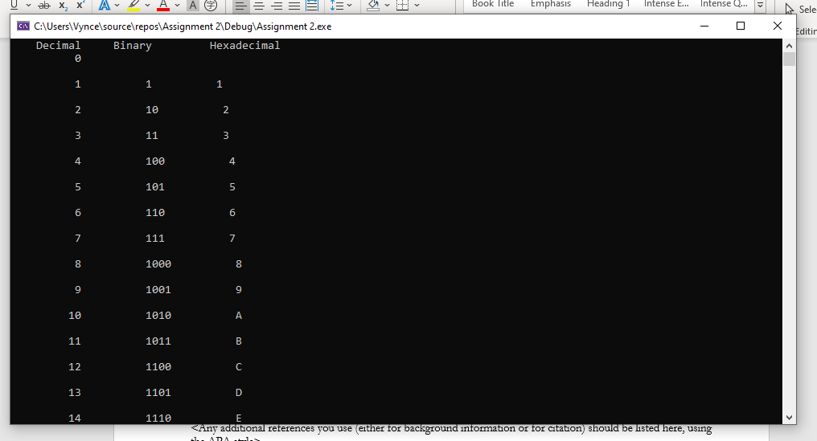

**1(b)**

**S/No Decimal Number Binary Number Remarks**

**.........................................**

**1 41.564 101001.10010**

**2 334.809 101001110.11001**

**3 169.480 10101001.01111**

**4 478.896 111011110.11100**

**5 962.747 1111000010.10111**

**6 705.859 1011000001.11011**

**7 281.514 100011001.10000**

**8 961.015 1111000001.00000**

**9 995.364 1111100011.01011**

**10 827.166 1100111011.00101**

**11 391.446 110000111.01110**

**12 902.005 1110000110.00000**

**13 292.378 100100100.01100**

**14 421.571 110100101.10010**

**15 718.607 1011001110.10011**

**16 447.663 110111111.10101**

**17 771.352 1100000011.01011**

**18 869.608 1101100101.10011**

**19 667.803 1010011011.11001**

**20 35.302 100011.01001**

**21 703.727 1010111111.10111**

**22 322.926 101000010.11101**

**23 673.142 1010100001.00100**

**24 141.235 10001101.00111**

**25 253.210 11111101.00110**

**26 547.844 1000100011.11010**

**27 663.000 1010010110.11111**

**28 37.392 100101.01100**

**29 723.297 1011010011.01001**

**30 529.024 1000010001.00000**

**.........................................**

**Press any key to continue . . .**

